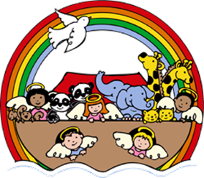
Bible Order Form

BIBLES FOR 1ST GRADE STUDENTS
Knowing the stories of the Bible is essential for the formation of our faith. Therefore, as a part of our commitment to our children, Ebenezer United Church of Christ has partnered with families to purchase children’s Bibles for all of our 1st Grade students.

The cost of the Bibles is subsidized by the church, so we ask that parents contribute $10. We also engrave the Bibles with the children’s names. This not only makes it a personal gift, but also makes it possible to know ‘whose is whose’ when several of them inevitably get left behind. Because the Bibles are engraved, we do not submit it for engraving until we receive the form below from the family.

The Bibles will be gifted to the first grade children on Sunday, September 11th (the first day of Sunday School) at the 8 am and 10:30 am worship services. Please take a moment to fill out the form below and return it to the church office with your $10 contribution. If the parent contribution is a hardship for your family, please talk to Rev. Lorri and arrangements can be made.

Thank you for partnering with us in the Christian Education and Faith Formation of your child.

Peace,
Rev. Lorri

__________________________________________________________________________________ First Grade Bible Order Form

Child’s Name (please print carefully)____________________________________________________

Parent(s) Name(s)________________________________________________

My Child will be present on September 11th to receive his/her Bible at the

8:00 am service ________ 10:30 am service _________

Received by____________________________________ Check #_____________ Cash_____________________

